Luca Stefanutti 40026602
Nov. 30 2019 Denis Rinfret
COMP 352 Assignement 3 & 4
1.
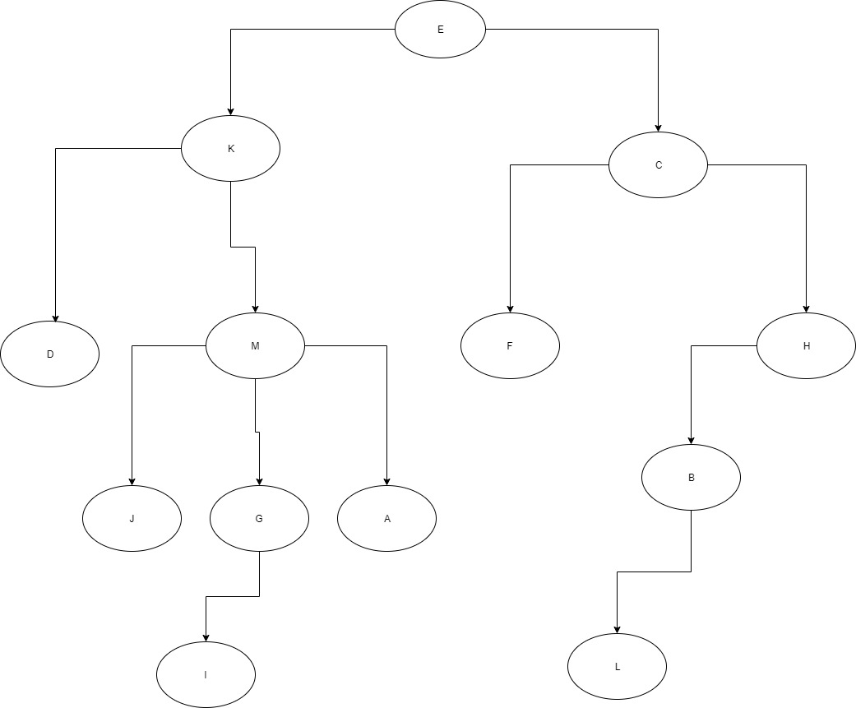

2. public class Question3 {

public static int [] smallestvals(int A[]) {
int temp [] = new int [A.length]; //to store the smallest values and the 0’s resulting from the 1st
loop

int j = 0; //index for the temp array
int count = 0;//to calculate the future size of the answer array

for(int i = 0; i < A.length; i++) {
//if the integer x, represented by A[i] is <= n represented by A.length, then that value is stored in the temporary array
if(A[i] <= A.length) {
temp[j] = A[i];
j++;
}
if(A[i] > A.length) {
//else it counts the empty spaces to be removed from temp
count++;
}
}
//to remove the extra 0s, we subtract the count of 0s from the total length of the original array, this will serve as the size of the answer array
int resize = A.length - count;
int answer[] = new int[resize];
//the values in temporary array are transferred into the answer
for(int i = 0; i < answer.length; i++) {
answer[i] = temp[i];
}
return answer;
}

public static void main(String [] args) {
int[] myArr = {12, 1, 4, 40, 60, 5, 10,88, 2, 100};
int[] someArr = smallestvals(myArr);
for(int i : someArr) {
System.out.println(i);

}
}
}

3. *See DrawIO and pdf files in order in the Q3A3&4 folder
The order is as follows:
Q3A3&4.pdf
Q3A3&4SortedHeap.pdf
Q3A3&4SortedAfterRemoveMinx1.pdf (returns 16)
Q3A3&4SortedAfterRemoveMinx2.pdf(returns 18)
Q3A3&4SortedAfterRemoveMinx3.pdf (returns 19)
In order to build the original unsorted heap using bottom up construction, empty tree nodes were created and then the integers from the provided list were inserted from the bottom layer of children node up until the top root node taking values from the list left to right.

To sort the min-heap, upsorting is applied until the tree becomes a min-heap where each value within the parent node is smaller or equal to the child nodes and the tree is a complete binary tree, meaning that the bottom layer of the tree is either filled up with all the possible nodes each parent node is allowed e.g. if there are 4 parent nodes then the bottom layer has 8 children nodes. If each node does not have its maximum amount of children then it must have one which is always a left-side child or none at all.

When the removeMin() function is applied, down heap is applied in order to regain the min-heap properties.

4.*See DrawIO and pdf files in order in the Q4A3&4 folder
The order is as follows:
Q4A3&4Start.pdf
Q4A3&4Upheap.pdf
Q4A3&4constructioncont.pdf
Q4A3&4ReMaxHeaped.pdf
Q4A3&4FinalMaxHeap.pdf

The first pdf depicts how the Maxheap is being constructed. Taking the values from the list left to right, the first integer is the original root of the heap, the next value takes the left child node and the right node takes the 3rd value in the list of values.
Before adding more new nodes, the values of each node to see if the values hold up the maxheap criteria. This criteria is two-fold, each parent node must be bigger or equal to children nodes and the max heap must be a complete binary tree. If these criterias are not met, the values are upheap until each parent node is <= its child. This is demonstrated in Upheap.pdf.
Q4A3&4constructioncont.pdf and Q4A3&4ReMaxHeaped.pdf are included to show that the same steps apply as values are added in left to right.

The final max heap is shown in FinalMaxHeap.pdf
5.i) Algorithm equalTrees(Node T1, Node T2), takes in two root nodes for T1 and T2 and recursively calls itself traversing all the n-child nodes and checking for equality of values, if both have the same number of nodes and same values contained in each node then they are equal. If none of the conditions are met, then returns false
Input: root nodes for T1 and T2
Output: boolean T or F if the trees are equal

equalTrees(Node T1, Node T2)
integer T1size ← T1.childList.size()
integer T2size ← T2.childList.size()
if T1 == null && T2 == null then
return true
if T1 == null || T2 == null then
return false
if T1 != null && T2 != null && T1.data == T2.data && T1size == T2size then
if !T1.childList.isEmpty() && !T2.childList.isEmpty() && T1size == 1 && T2size == 1
return equalTrees(T1.childrenList.get(T1size--), T2.childrenList.get(T2size--))
else if !T1.childList.isEmpty() && !T2.childList.isEmpty() && T1size > 1 && T2size > 1
while(T1size != 0 && T2size != 0)
return equalTrees(T1.childrenList.get(T1size--), T2.childrenList.get(T2size--))
else if T1.childList.isEmpty() && T2.childList.isEmpty()
return true
return false

Algorithm issubTree(Node T1, Node T2) takes in two root nodes for T1 and T2, uses equalTrees to check if T2 is a subtree of T1. T2 is a subtree of T1 if T2 has all its roots and child nodes contained within T1. T2’s last descendants, if they are contained within T1, MUST point to null for T2 to be a subtree.
Input: root nodes T1 and T2
Output: boolean T or F, T if T2 is a a subTree of T1, false otherwise

issubTree(Node T1, Node T2)
integer T1size ← T1.childList.size()
if T1 == null && T2 != null then
return false
if T2 == null
return true
if(equalsTrees(T1, T2) == true)
return true
else
while(T1size != 0)
return issubTree(T1.childList.get(T1.size--), T2))
return false
ii)In terms of time, to find if Trees are equal, with the use of a while loop in order to recursively call the function on all the child nodes of a given node will make the run time run in O(n), all other check conditions take O(1)and the recursive call when there’s only one child runs in O(1) since there is no iteration making the entire equalTrees() algorithm run in O(n). issubTree() uses a while loop to recursively call the function for every child of T1, where then equalTrees() is called using the children of T1 and the root of T2. The while loop for calling issubTree on each n child runs in O(n), the call for equalTrees() runs in O(n), all the other if conditions are O(1). Since we recursively call issubTree() n number of time depending on the children and equalTrees is called n number of times to see if a given child node contains T2’s root and all other nodes, the entire issubTree runs in O(n²)
iii) The algorithm will still work if there are duplicate values. The equalTrees() method will skip all the if conditions for null values. Since equalTrees() checks the data of one node at a time in each recursive call and the amount of children of each node, it will continue to perform its operations and correctly return true or false. Since issubTree() requires equalTrees() to function correctly, it too will still work.
6. The first proposal will affect search time in the same way the AVAILABLE object would otherwise. It will have the same functionality and performance as if the AVAILABLE object would have been used so there will be no errors in functionality or performance. In some instances it may reduce search time but worst case it will search in O(n) if the hashed key is located at the very end of the array or if the search begins at an arbitrary index I, searches up until Array length N, loops back to index 0, and finds the searched key at I – 1.

The second proposal can improve search time since in worse case, there will always be 2 values corresponding to the searched value within the hash table, the 1st value will be the hashed value meant to have been hashed as a given index I (let us call it p) and the 2nd value is the value at index I where p was originally supposed to be placed. Search time will never be O(n) since it will never be necessary to loop through all the values of the array to find the hashed value. In best cases it can run in O(1), where say searched key k is found at index 0 because k was orginially mapped to 0 but with collision was moved to array length – 1. Where as normally it would have needed to O(n) to search until the end of the array, now that removed values are replaced with keys that are meant to have been hashed at their original index, search time can be significantly reduced. Functionality is not an issue, however, removal can still run in O(n) and thus hinder performance. For instance if a value is removed at index 0, and the key meant to have been hashed at index 0 is now located at index array length – 1, then removal must search for that value and loop through every entry at worst in order to find the key that should have been placed at index 0.

7.i) h(32) = 32 mod 13 = 6
h(147) = 147 mod 13 = 4
h(265) = 265 mod 13 = 5
h(195) = 195 mod 13 = 0
h(207) = 207 mod 13 = 12
h(180) = 180 mod 13 = 11
h(21) = 21 mod 13 = 8
h(16) = 16 mod 13 = 3
h(189) = 189 mod 13 = 7
h(202) = 202 mod 13 = 7
h(91) = 91 mod 13 = 0
h(94) = 94 mod 13 = 3
h(162) = 162 mod 13 = 6
h(75) = 75 mod 13 = 10
h(37) = 37 mod 13 = 11
h(77) = 77 mod 13 = 12
h(81) = 81 mod 13 = 3
h(48) = 48 mod 13 = 9
*ALL ABOVE VALUES GENERATED BY THE HASH FUCYIONS EQUATE TO INDICIES IN THE ARRAY OF LENGTH 13*
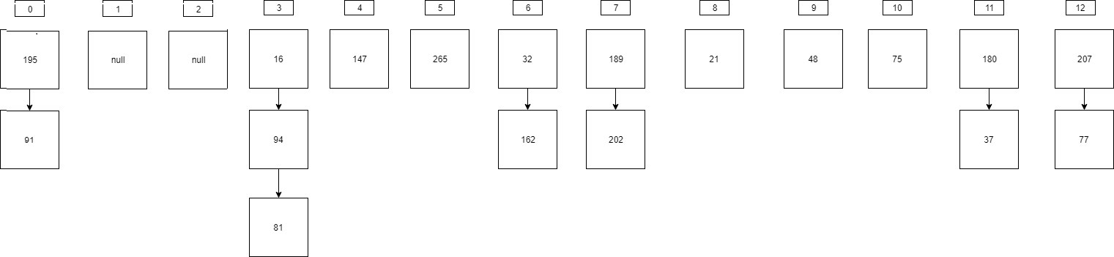
ii) The maximum number of collisions that occurred were at index 3 with a total of three maximum collisions resulting in a longer chain of values stored at index 3 of the array.

8. This proposal does hold validity since increasing the size of the array reduces the load factor and allows values to be placed into more indexes in the array, reducing the chance of collision. For Separate Chaining the ideal load factor should be kept < 0.9. The proposed load factor would be 13 current entries / 15 total spaces in the proposed array = 0.8666.. which is < 0.9.
9. i)*See Q9A3&4.pdf and io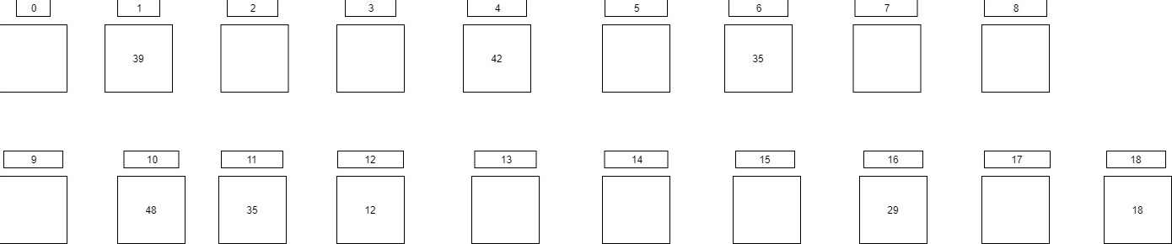
ii) The size of the longest cluster is located between indexes 10 and 12 and thus has a size of 3.
iii) The total number of collisions is 8 as a result of the operations.
iv) Load Factor = number of keys in hash table / total length of hash table = 8/19 = 0.42
Q10.
832 | 91 | 411 | 91
91 | 411 | 326 | 96
411 | 832 | 832 | 172
172 | 172 | 243 | 243
243 | 292 | 172 | 292
573 | 682 | 573 | 326
326 | 243 | 682 | 411
292 | 573 | 489 | 489
682 | 326 | 91 | 573
489 | 96 | 292 | 682
96 | 489 | 96 | 832

Q11.i) *See AVLoriginal.pdf/io and AVLFixed.pdf/io The error is located with the “zigzag” subtree 82, 75, 81 which has a height of 3 as opposed to the external node 2 which has a height of 1. At most there can only be a height difference of 1 between child trees. As a result of this error the tree is unbalanced on the right side with node 84 having a height of 5 compared to 29 with a height of 3. To fix the error we find the node where the error originates and label it z. From z we go to the child node with the biggest height, label it y and repeat the process to label one last node x. We then name each node a, b and c using inorder(L, Root, R). Two rotations will occur making b the new parent node, a the left child and c the right child. A’s children become a’s left child and b’s left child, c’s children are b’s right child and c’s right child. The resulting tree is an AVL trees because the difference in height between two children subtrees is <= 1
ii) *See AVLput74.pdf/io The Big-O complexity for this insertion is O(log n) due to traversing the entire height of the tree which is log n, insertion itself being O(1). The traversal causes the entire O of the operation to be log n.
iii) *See AVLremove62.pdf/io The traversal to find 62 has a big O(log n), removal takes O(1), and rearranging the edges for each node to keep the properties of a binary search tree takes O(log n). So overall the bigO of the entire operation is O(log n).
iv) *SeeAVLremove93.pdf/io The traversal of the tree has a big O(log n), removal takes O(1), to rearrange the imbalanced height of the AVLTree takes O(log n), rearranging the edges to keep to the property of a binary tree takes O(log n), overall the Big-O is log n.

